EventApp – An applicant’s guide





For use with Eventapp v4

Contents

Introduction 3
Getting Started 4
Home Page 4
Before you start an application 5
Logging In 5
Making an Application 6
Your Details 6
Insurance 7
Invoice 8
Event Information 9
Venue information 10
Schedule information 11
Event Checklist 12
Supporting Documents 13
Managing your application 14
User Dashboard 14

Introduction

EventApp is a simple, intuitive and user-oriented online event application process. The system provides event organisers with a fast and efficient way to apply for permissions, allowing you to get on with organising the event.
You can apply for associated permits, find locations and local authority officers can respond to applications and requests at the click of a mouse.
This document describes how to use the system to make an application for an event. We hope you find this process intuitive and simple. The following guidance will guide you through each step and explain anything which may be unclear. If you have any questions or feedback please let us know at support@apply4.com.
There is an online support area with several training videos at www.apply4.com/support

Getting Started

Eventapp Front Page

To see an example of a Front Page go to: https://app.apply4.com/eventapp/uk/demouk.

Most applicants start on the Eventapp front page. If you a permitting authority has directed you to Eventapp this is where you will arrive.

This page contains:
- any information from the permitting authority that you need to know before you start,
- ‘Useful Documents’ in the bottom right hand corner - you can download them by clicking on them,
- the button to start your application: 'Apply for Permit'.

'Useful documents' are documents that the permitting authority thinks are necessary for you to access. This may include:
- location specific guidelines
- information about fees and charges
- supplementary application forms that you may need.

Registering as a new user
The registration page can be reached via the following link: https://app.apply4.com/users/sign_up.
If you are at a Eventapp front page you can reach the registration page by clicking ‘Apply for Permit’ and then ‘Register’ in the top right of the page.
If you are at https://app.apply4.com/ you can reach the registration page by clicking ‘Register’ in the top right of the page.
Once you are on the registration page please:
- enter all your details
- read our terms and conditions and confirm that you have
- read our privacy policy
- confirm that you are not a robot
When you have done this click ‘Create’.
Once submitted you will receive an email asking you to confirm account creation. To do this you need to click on the link in the email. This link is in the text: ‘Confirm my account’. You need to do this before you can access the account. If you do not receive a confirmation email you can get it resent from the following page: https://app.apply4.com/users/confirmation/new.
When you click on the link it will direct you to the permitting authority you were applying to. There will be a green bar at the very top of the page that confirms you have been successful. You will also receive an email letting you know you have been successful.

Before you start an application

Logging In
The login page can be reached via the following link: https://app.apply4.com/users/sign_in.
From the front page you can reach the login page by clicking ‘Apply for Permit’.
From https://app.apply4.com/ you can reach the login page by clicking ‘Login’ in the top right hand corner of the page.
If you have forgotten your password you can click ‘Forgot your password?’. This will take you to a page where you reset your password by writing in the email you used to register. This will then send that email address an email. This email will contain a link to a page where you can change your password.

Making an Application

The Basics
Throughout the application fields marked: ‘*’, are mandatory.
Hovering over the blue question mark gives further instructions about the question or field.
You can navigate through the application by clicking on the different tabs on the left hand side of the page. When you have completed all the necessary information in a section the tag will have a green circle with a tick to its left. If more information is required then the circle will be grey.
Click ‘Next’ to progress to the next section or ‘Previous’ to go back. You can also navigate between sections by clicking on the different tabs. Progress is saved as you move between sections.
You can save your application as a draft at any time by clicking ‘Save as draft’. Having done this you can log out and come back to the application at a later date. The application is also saved at regular intervals automatically as you progress through it.
The Submit Application button is shown as you progress through the application but you will not be able to submit until all required fields have been completed.

Your Details
Enter details of the organiser or company responsible for the event.
Next you are asked for previous event management experience.
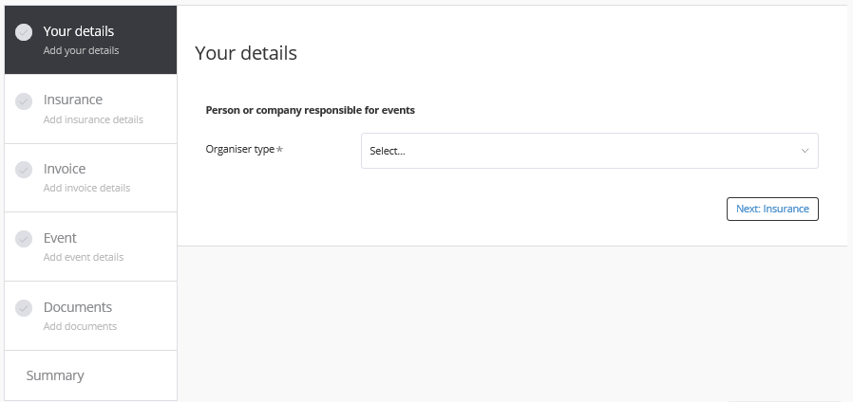
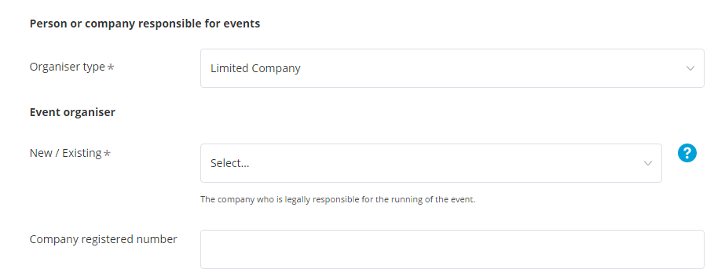
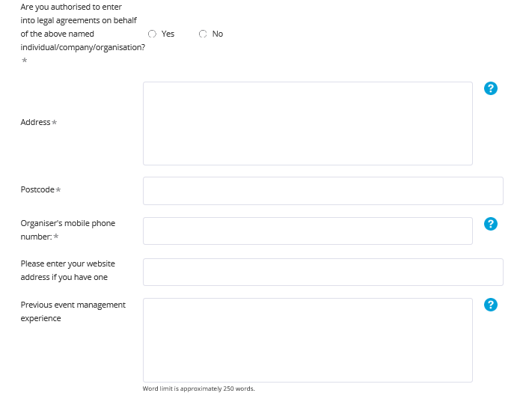
If you are not authorised to enter into legal agreements, the contact details of that person needs to be provided.
Specifying the organiser type ensures that the correct information is provided

Insurance
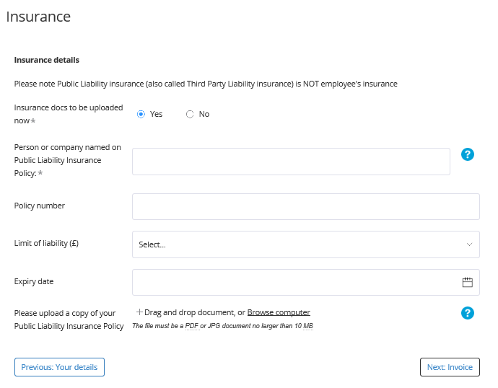
You can upload proof of public liability insurance now.
If you do not have public liability insurance to hand tick the No box. If you select ‘No’ you must upload these documents at a later date. You can do this through the ‘Document summary’ section of the saved application.

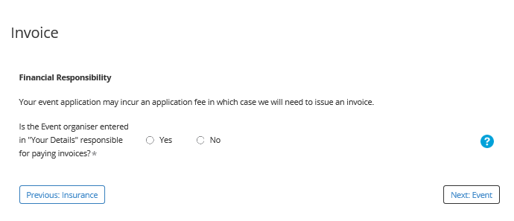
Invoice
If someone other than event organiser contact is responsible for dealing with invoices, please enter their details.

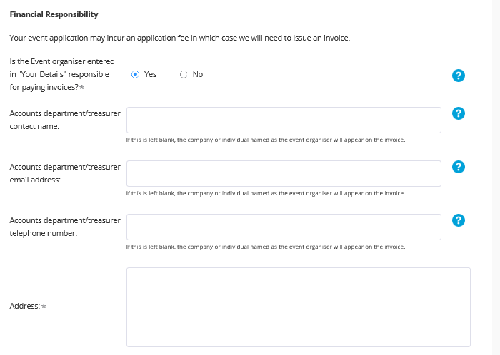
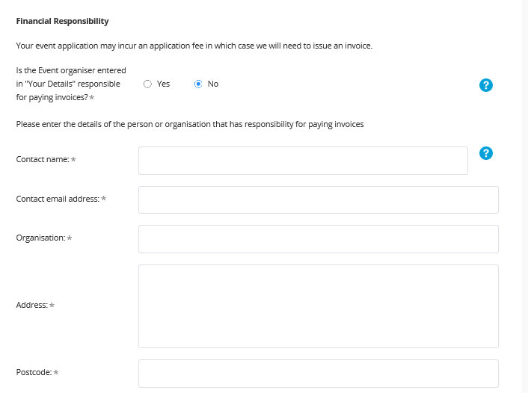

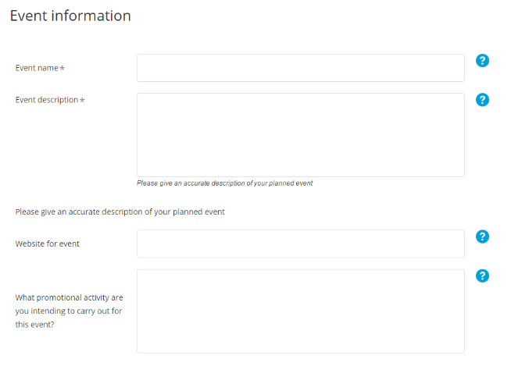
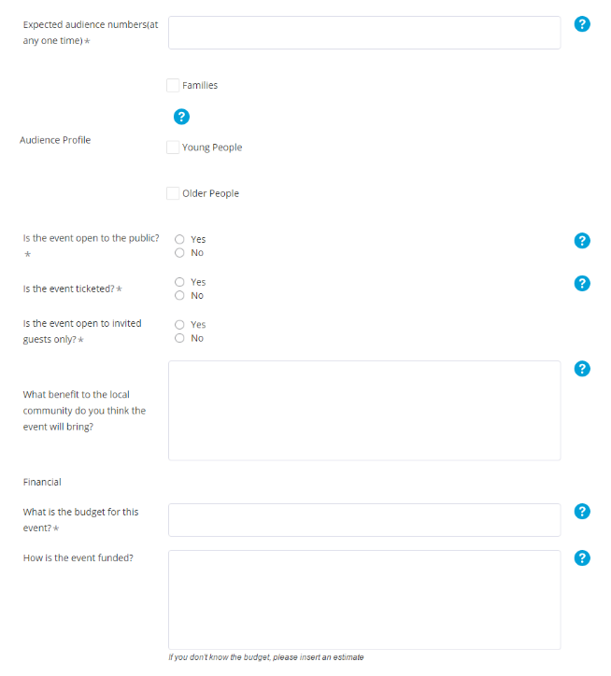
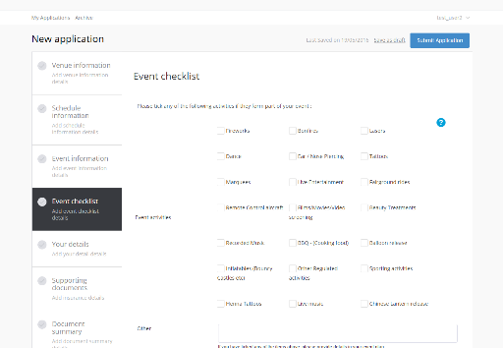
Event Information
In the second part of the event information section you are asked to enter more detailed information such.
Enter information about the target audience.
You must specify if the event is open to the public, if it is ticketed and if it is by invitation only.
Finally enter information about funding.
EVENT INFORMATION
In the first part of this section you are asked to name and describe the event.
If a website for the event exits, please enter the address.
Describe how you will promote the event.
Using the tick boxes select the event type or add your own using the ‘Other’ field.
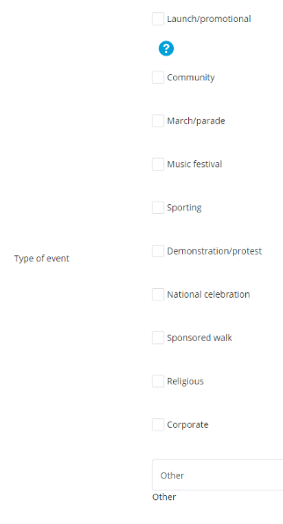

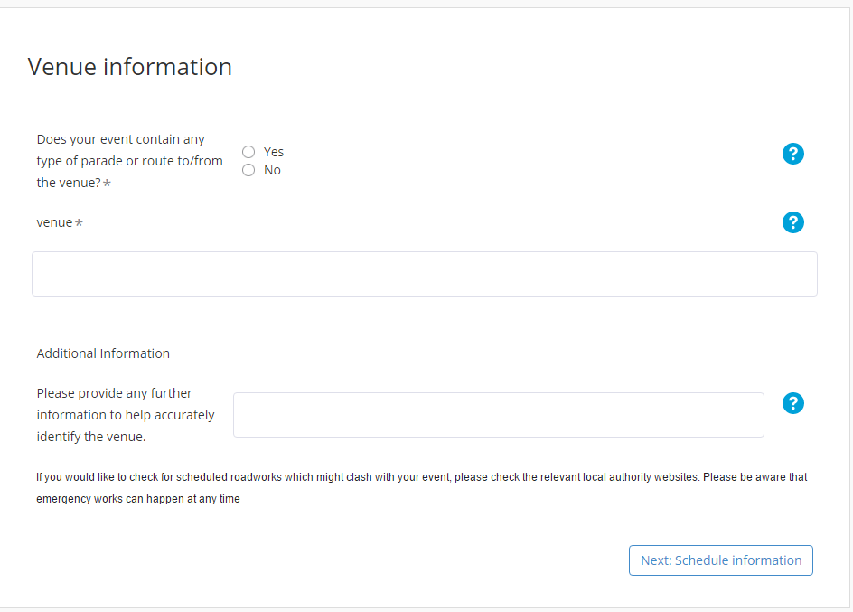
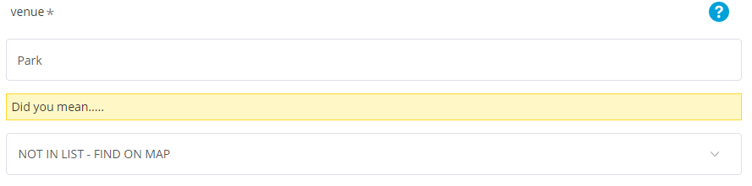
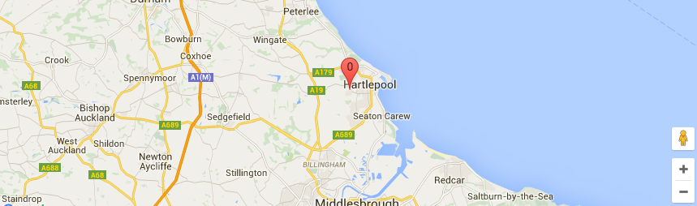
Venue information
STATIC LOCATION
If the event does contain a static element enter the location name in the ‘Venue’ field.
If you type in the name of a location which already exists in our database you will be able to select it from the list which appears.
If it is not in our database select ‘NOT ON LIST – FIND ON MAP’.
You will then need to select the type of location (e.g. Park) and enter information to accurately locate the venue.
PARADE OR ROUTE
This is the first part of the application where you enter venue details.
If the event contains a parade or route element click ‘Yes’ and you will be asked to provide route details.
If the event has no static element type the word “route” in the ‘Venue’ field.
If the event does contain a static element

Schedule information
SCHEDULE INFORMATION
Start and end dates and times are specified in this section.
Clicking in the date fields will display a calendar. The same is the case for the time fields.
If preparation time is needed further fields will be displayed to capture this information.
If there is filming out of hours a free text field will appear to capture details about this.
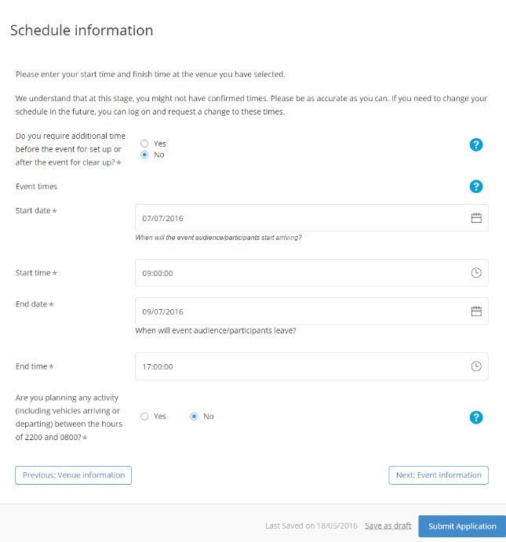

Event Checklist
EVENT INFORMATION
This section collects detailed information about event activities and safety aspects of event planning.
The first question tackles event activities. Tick the relevant boxes or use the free text box to enter anything not covered by the multiple choice answers.
Do the same for the waste management and facilities questions.
After this you are asked to provide event safety information by answering a number of questions by indicating ‘Yes’ or ‘No’.
Do the same for required consent and permissions.

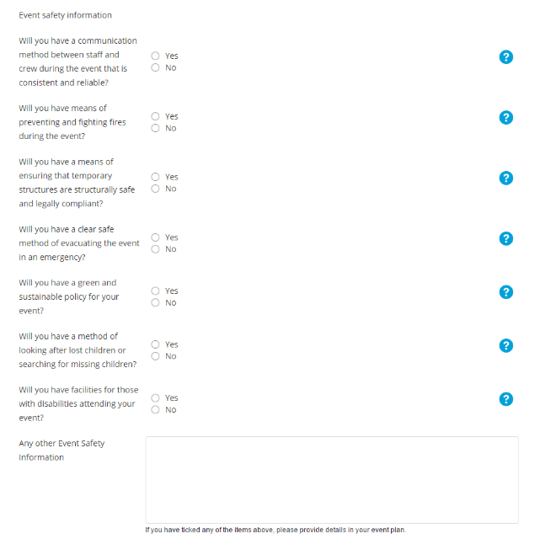
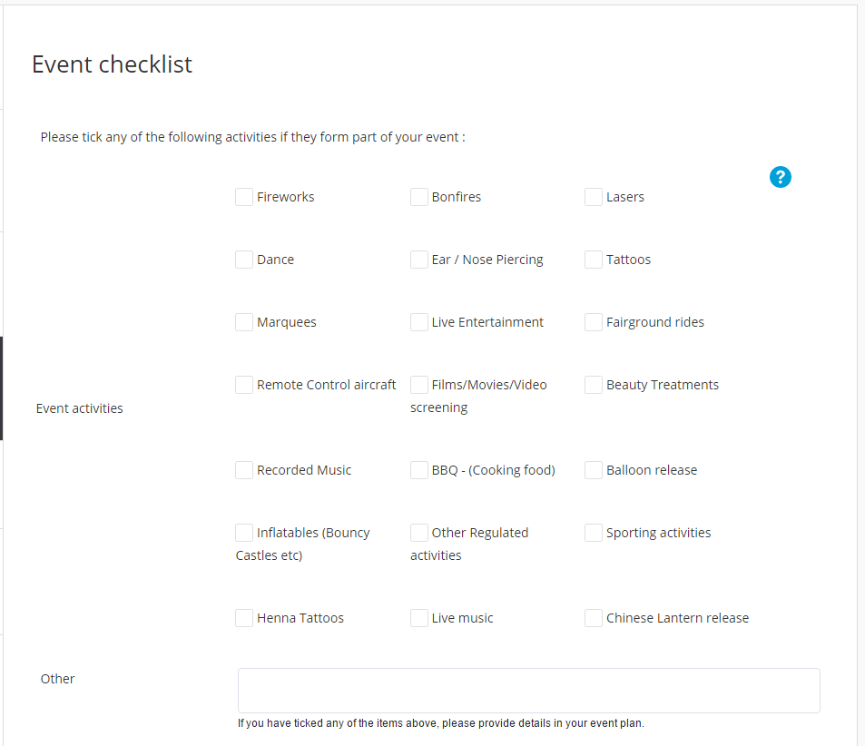
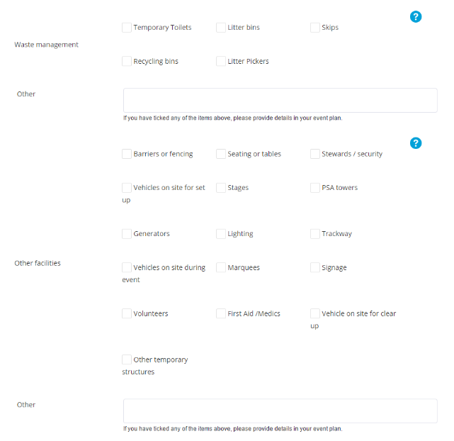

Supporting Documents
If you have additional documents to submit (e.g. site map, additional planning documents) you should upload them here.

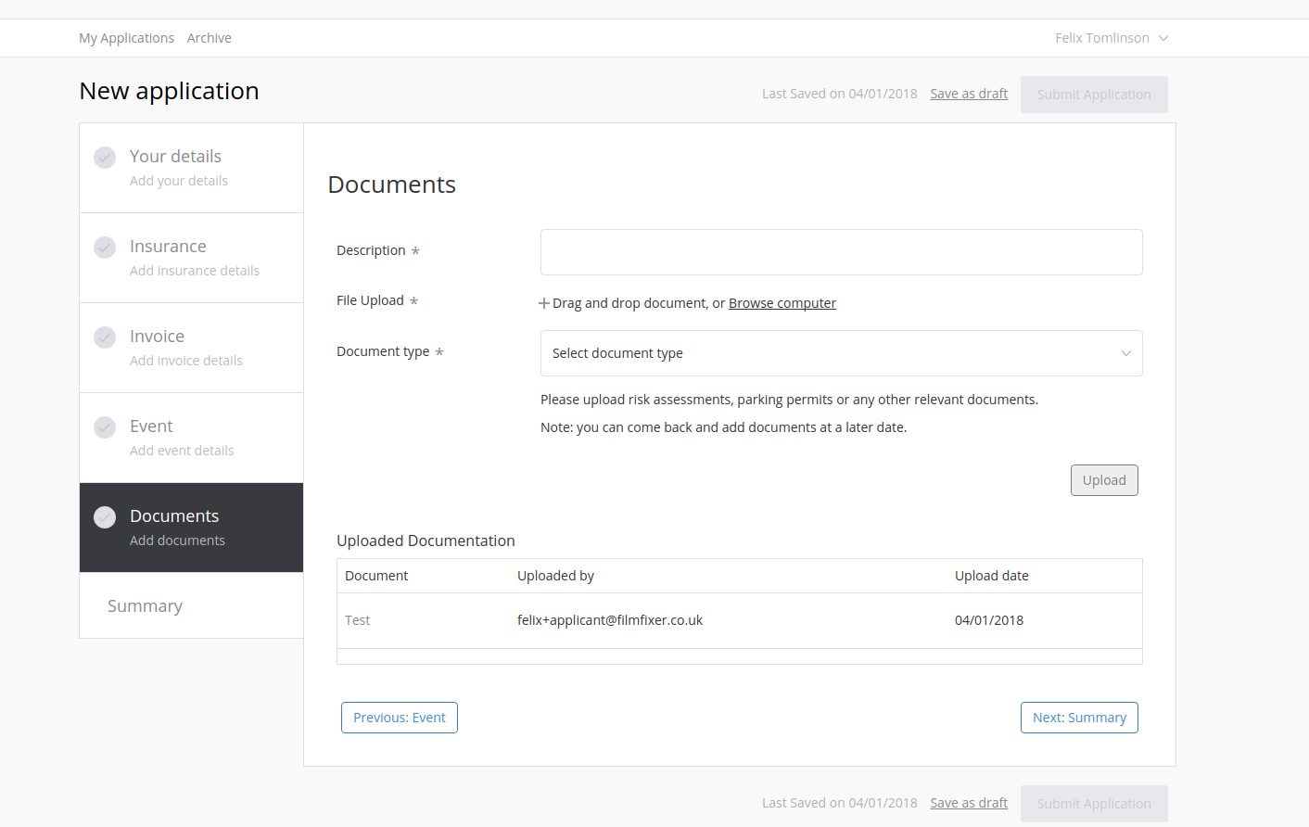

Enter the document name and click on ‘Browse computer’ to choose the appropriate file.
Click ‘Upload’ to attach the document to your application.
Uploaded documents will be listed here. Use the drop down menu to delete unwanted files.

Managing your application

User Dashboard
This page displays drafts and previously submitted applications. It allows you to see the documents you have submitted as well as the dates of your applications.
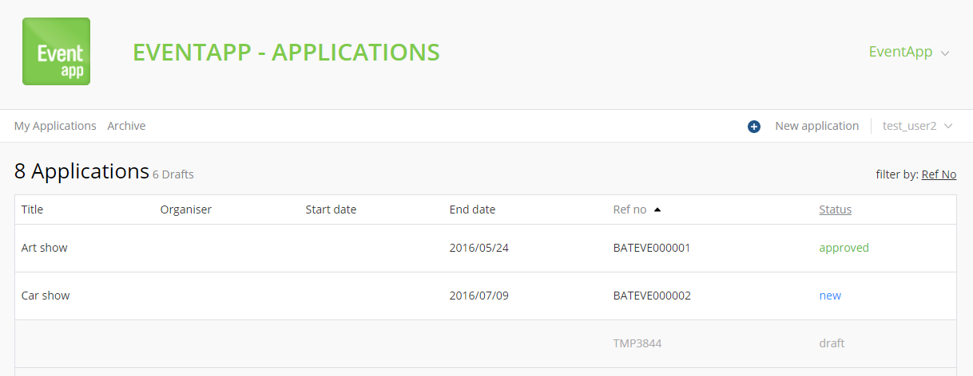
To view and edit user settings click on the drop down arrow
The status quick view shows the status of each form:
new – awaiting review by administrator
draft – not yet submitted
Click here to create a new application
Users can also view archived applications

Application status
Each application will have a status assigned to it:
draft – an application has not been submitted
new – a completed application has been created and is awaiting review by administrator
current – the application has been received and is being processed
approved - a licence for the event has been issued
completed – the licence was issued and the event date has passed
info req – the licencing authority has requested some additional information, an email would have been sent to you with details
resubmitted – an application you resubmitted having provided additional information or documents

Uploading additional documents
When the permitting authority has requested additional information, it will frequently require you to upload additional documents. You can do this AT ANY TIME, regardless of whether the application is locked, by clicking on the folder icon under the documents column on your applicant dashboard.
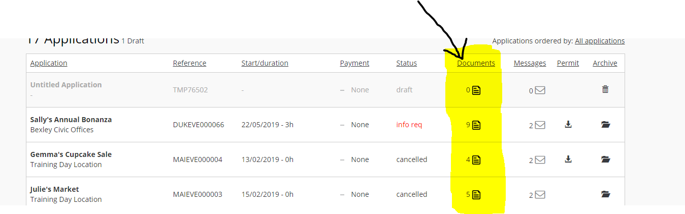
Enter the document name, browse for the document on your computer, select to which event it relates to and click ‘Upload’.

