**Event Management Plan**

**Name of Event**

**Dates of Event**

|  |  |
| --- | --- |
| **Version** | **Date** |
| 1 | dd/mm/yyyy |
|  |  |
|  |  |

**Contents**

Glossary 3

Plan Production and Control 3

Plan Aims and Objectives 3

Event Outline 3

Event Activity and Timing 3

Event Management Team 3

Control Centre 4

Security 4

Crowd Management 5

Traffic Management (CSAS) 5

Road Closures 5

Public Transport Management 5

Medical Cover 5

Severe Weather Plan 5

Power Supply 6

Fire Precautions and Equipment 6

Incident Reporting 6

Emergency Procedures 6

Lost Person Procedure 7

Lost Person 7

Found Persons 7

Evacuation Procedures 7

Suspicious Items Procedure 8

Bomb Threat Procedure 9

Communications 10

Media 10

Public Address Scripts and Media Holding Statement 10

Waste Management 10

Toilets 10

Lighting 10

Noise Management Policy 10

Fairground Traders 10

Catering Providers 10

Alcohol Traders 11

Equality Impact Statement 11

Insurances 11

Risk Assessment 11

Appendix 1: Site Plan 11

# Glossary

Enter any abbreviations you use throughout you plan and the full name/meaning.

|  |  |
| --- | --- |
| **Abbreviation** | **Full Name/Meaning** |
|  |  |
|  |  |
|  |  |
|  |  |

# Plan Production and Control

This plan has been produced by insert name, insert job title if applicable, insert organisation name.

# Plan Aims and Objectives

* To facilitate the running of a safe event.
* To identify and consider contingency plans for problems that may arise.
* Identify the trigger points at which contingency plans may/must be implemented.

# Event Outline

Give an overview of the event including where it is to be held, when it is to be held and the activities it will entail.

# Event Activity and Timing

|  |  |  |  |
| --- | --- | --- | --- |
| **Activity** | **Day** | **Timing** | **Responsible** |
|  |  |  |  |
|  |  |  |  |
|  |  |  |  |
|  |  |  |  |
|  |  |  |  |

# Event Management Team

The EMT will be made up of the following representatives and responsibilities:

|  |  |  |
| --- | --- | --- |
| **Role** | **Named Person/Organisation/**  **Contact** | **Responsibilities** |
| Event Manager | Insert name, organisation and contact telephone numbers | Overall event responsibility:   * Strategic decisions regarding delays/ cancellations/emergency procedures. * Manage event personnel and resources.   Managing event operations:   * Oversee and coordinate timings of event elements. * Liaise with stakeholders – Oversee deployment of staff and resources at event. * Carrying out agreed contingency plan procedures, to assist staff, volunteers, public and emergency services. * Oversee build and management of the event site defined as: Market Place, Brewery Plain. |
| Deputy Event Manager | Insert name, organisation and contact telephone numbers | * To support and deputise for the event manager in the aforementioned duties. |
| CSAS Traffic Manager | Insert name, organisation and contact telephone numbers | * To manage the road closures. * To manage traffic movement. |
| Security |  | * Event safety. |
| Medical Lead | Insert name, organisation and contact telephone numbers | * To manage all requests made for medical assistance, along with recording all medical related issues. |
| Communications | Insert name, organisation and contact telephone numbers | * Look after comms messages for the duration of event. * Lead comms and press should there be any emergency. |

# Control Centre

The event control centre will be based insert location. Add if staff welfare are available.

# Security

To ensure the safety of staff and visitors insert security company name the following SIA will be in position:

|  |  |  |  |
| --- | --- | --- | --- |
| **Day** | **Time** | **Location** | **No’ of CSAS** |
|  |  |  |  |
|  |  |  |  |
|  |  |  |  |
|  |  |  |  |

License numbers of the SIA team are available on request from insert security organisation name and email.

# Crowd Management

* Describe how crowd will be monitored and managed.
* Detail any potential bottle necks.
* How many visitors are you expecting, at any one time and over the duration of the event?

# Traffic Management (CSAS)

Norfolk Constabulary accredited CSAS staff will be provided by insert organisation name and contact.

There are road closures in place at the following locations:

* Location one.
* Location two.
* Location three.

The following numbers will be present at these locations and times:

|  |  |  |  |
| --- | --- | --- | --- |
| **Day** | **Time** | **Location** | **No’ of CSAS** |
|  |  |  |  |
|  |  |  |  |
|  |  |  |  |
|  |  |  |  |

License numbers of the CSAS team are available on request from insert organisation name and contact.

# Road Closures

Detail the road closures that will be place and include a site plan if possible.

# Public Transport Management

Detail if buses will be affected and how this will be managed.

# Medical Cover

Medical Cover will be provided by insert organisation name and the following cover will be provided:

* Detail the level.

Insert organisation name EMP available on request.

It is noted that a summary of injuries that must be reported to the enforcing authorities including:

* Death.
* Major injury e.g., where a person is taken to hospital or for a broken bone, loss of consciousness.
* Dangerous occurrence e.g., structural collapse.

These details will be recorded by insert event organisation name and medical organisation.

# Severe Weather Plan

The weather forecasts will be monitored prior to the event and during it. Severe rain and high wind may necessitate either the suspension or cancellation of the event.

The following is in place to assist the decision-making process:

* Strong winds with high constant gusts over 50 mph – event cancelled.
* Torrential rain in the lead in period to set up and opening with flooding limiting set up and access – full site assessment carried out pre-opening with the potential of event being cancelled.
* Lightning and thunderstorms – the PLASA guide to electrical storms [Lightning Guidance for Outdoor Events – PLASA](https://www.plasa.org/lightning-guidance/) will be used as guide to decision making.

Should the event be cancelled all radio stations will be informed as follows:

***“It is with great disappointment that the insert event name has had to be cancelled due to severe weather conditions on site.”***

Radio Station contact list:

* Radio station one.
* Radio station two.
* Insert event organisation name media platforms will be updated accordingly.

# Power Supply

Detail any power requirements, how they will be met safely.

# Fire Precautions and Equipment

Detail what is required onsite and whether traders you have attending will be required to supply their own.

# Incident Reporting

All staff/stewards will be briefed prior to the event opening to members of the public this briefing will include details on site reporting procedures and use of radios on site.

Any incidents must be reported to the Event Manager/Deputy Event Manager who will log the incident details.

Should an incident occur that is notifiable, a near miss or injury on site that is RIDDOR reportable this will be carried out by the Event Manager/Deputy Event Manager with the incident information passed onto Great Yarmouth Borough Council Environmental Health.

The entire site will be inspected by the Event Manager/Deputy Event Manager before opening, to identify and rectify any issues identified on site that may lead to trips, slips, or falls to members of the public or other potential hazards that require remedial action.

# Emergency Procedures

The EMT will meet at the beginning of the day and confirm the following in the event of an emergency:

* Who to contact?
* The detail of the incident requiring further action or support.
* Report to services as required in order to escalate.
* Deployment of stewards as necessary, medical and escalate to Emergency services as required.
* The pre-event team meeting will convey the need to always ensure public safety and to ensure emergency routes and access are maintained.

# Lost Person Procedure

All staff/stewards will be briefed in the following actions if a lost child/ vulnerable person is reported missing or found within the event footprint.

## Lost Person

* If a parent or guardian reports a child/ vulnerable person as missing.
* The full description will be shared with all radio holders as a “insert code.”
* All stewards will sweep their area to assist in locating the lost child.
* If the child is located the stewards should stay in the area where the child has been located and report this to the On Duty Event Manager.
* Police will be informed via the persons parent/ guardian/ relative carer if a person is not found after a period of no less than 10 minutes.

## Found Persons

* Stewards will work in pairs with the found child/person “insert code located “.
* The child is not to be moved from the location they are found in.
* The site will be swept for the parents or guardian of the lost child.
* Once re united – certain identification checks should be carried out to ensure the parent or guardian is related to the lost person.
* The following details are required, name, telephone number and address, relationship to lost person, as parent, grandparent, or guardian.
* Proof of identity is required (if the child is seen to be nervous or unwilling to be reunited).

# Evacuation Procedures

If the EMT considers an emergency to be declare, then operational command will fall to the Norfolk Constabulary. The primary rendezvous point will be insert location, with the secondary situated on insert location.

A major incident could involve:

* Fire.
* Structural collapse.
* Bomb threat.
* Major crowd disorder.
* Explosion.
* Flash flooding and other extreme weather conditions.

An emergency service Rescue Vehicle point will be established on the carriageway. From there the operational commander will task and control the response.

If the EMT decide that a controlled evacuation of event site is required, then the following procedure will be used if possible:

* Decision is clearly recorded - time taken and reason given by the Event Manager along with being recorded.
* Visitors and exhibitors will be escorted away from the venue by event staff, stewards and CSAS staff if appropriate.
* People will be asked to leave via the safest route if it is deemed to be safe.
* If deemed safe the event Staff, SIA and CSAS staff if appropriate, will spread across the entrance to the site to stop re-entry.
* If an evacuation occurs due to a bomb threat or suspicious package (see Suspicious Items and Bomb Threat procedure) a secondary evacuation location will be used by the event organisers. This location will be determined before the opening of the event and will only be known by the operational EMT.

# Suspicious Items Procedure

Reports of or finding an item will be regarded as suspicious if its location cannot be immediately explained or the package returned to the owner. Staff who find an unattended/ suspicious item should follow the H.O.T procedure.

* **Hidden:** Has the item been hidden, can it be easily seen, has it been concealed?
* **Obvious:** Does it have visible wires, is it making a sound, can you see a timer, is it leaking, is there a gas emitting from the item?
* **Typical:** Is it expected in the location it has been found.

It is vital the EMT is informed regarding the unattended/ suspicious items.

Radios and mobile devices carried by the individual who has found the item must be switched off if they are within 15 metres of the item. Messages will be passed by relay to staff outside of the area.

It is essential to note the following code phrase will be used:

* **“Mr Case is at (Add location), Mr Case is at (Add location)”**

The person relaying this information will provide a brief description on what measures they have taken to date for example if they have asked if the package belongs to anyone? Has the area around suspicious item been cleared?

The operational EMT will consider the four c’s when dealing with the suspicious item:

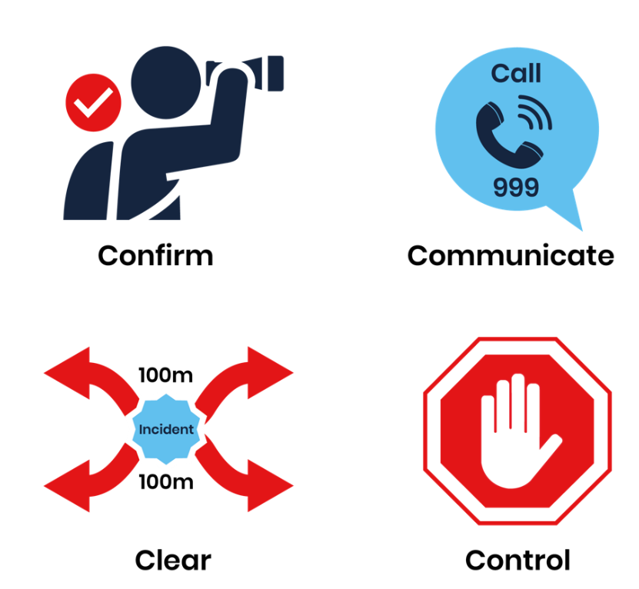

If an area is to be cleared the team clearing the area should use the distances as listed below:

* Briefcase/ Rucksack: 100 metre cordon.
* Suitcase/ car: 200 metre cordon.
* Van/ lorry: 400 metre cordon.

The Event Manager will issue instructions or the Deputy Event Manager on the next steps along with informing the authorities if required.

# Bomb Threat Procedure

Threats of this nature must always be treated seriously and not dismissed as a hoax whether it is directed at the GYBC. A threat can be received via phone, text, email, social media message. The person who receives the threat should follow the procedure illustrated simply in the graphic below.

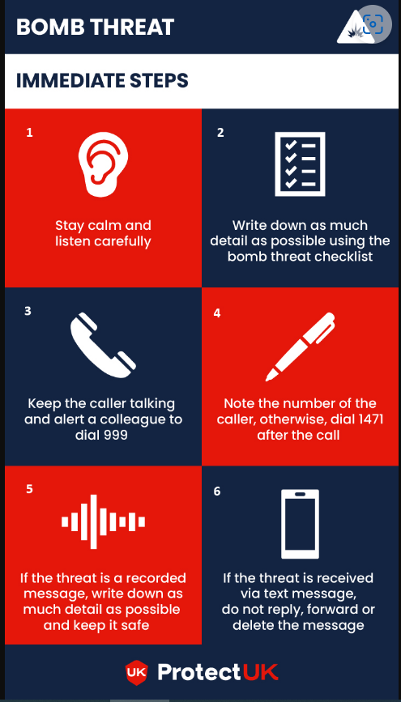

Source. [Bomb threats | ProtectUK](https://www.protectuk.police.uk/bomb-threats)

As soon as the EMT is made aware of the developing scenario they must ensure the following procedure is followed:

* Inform the Police immediately.
* Log the details of the threat as soon as possible along with recording as much information as possible.
* Continue to log all further actions and decisions relating to the bomb threat.
* Based on the advice of the Police in relation to the threat, the EMT must take the decision to evacuate or partially evacuate the event site.
* Event Manager and Deputy Event Manager to start a search of the event site for the suspicious item.
* Work with the Event Manager and the Deputy Event Manager to instruct and task Stewards and CSAS to assist with putting cordons in place.

# Communications

The event team will use radios and mobile phones for communications. No difficulties are anticipated with the mobile phone network.

Radios for communications will be issued to the event team for onsite communications. The following code words will be used by the radio users:

* **Code insert code:** Site evacuation to be called by Event Manager or Site Manager.
* **Code insert code:** Radio silence be on standby to evacuate.
* **Code insert code:** Authorities called to venue.
* **Code insert code:** Fight/ anti-social behavior.
* **Code insert code** Missing person radio silence required for information to be transmitted.
* **Code insert code:** Medical Incident.
* **Code insert code:** Suspicious Item.

The EMT will have a list of essential telephone numbers on them at all times.

# Media

Details any pre-event publicity that will take place and during the event.

## Public Address Scripts and Media Holding Statement

Detail statement that will be put out in the case of emergency.

# Waste Management

Detail how this will be managed and whether you have a waste management company involved.

# Toilets

Details of toilets that will be available for the public to use and how they will be managed.

# Lighting

Details of how the event area will be lit if taking place from dusk.

# Noise Management Policy

If music is being played and fairground rides in place, detail how noise levels will be managed.

# Fairground Traders

If in attendance detail certification, licenses and insurances that will need to be in place.

# Catering Providers

Details of catering traders that will be in place.

Catering providers have to provide proof that they:

* Are registered with a council.
* Have evidence of competency in food hygiene (e.g. food hygiene certificate).
  + Ideally with a star rating of 4 or 5.
* Have documented evidence on safe food handling practices, fire, gas and electricity as appropriate.
* Have waste disposal arrangements.

# Alcohol Traders

Details of any trader selling alcohol during the event, licenses required, insurances and whether a TEN is required.

# Equality Impact Statement

Every effort is made to consider the needs of all members of the public, including those with disabilities. All cables around the event to be covered.

# Insurances

The event is covered by insert event organisation name insurance through insert insurance provider.

Details of insurances in place for security, CSAS and medical providers.

All traders must provide evidence of at least insert amount public liability cover.

# Risk Assessment

Available on request.

# Appendix 1: Site Plan

Add any site plans.