ISLINGTON FILM OFFICE
Finsbury Square Unit Bases Application Form

- Please complete and return to info@islingtonfilmoffice.co.uk
- A minimum of 10 working days’ notice is required for the
- A minimum of 5 working days’ notice is required for P&D bays
- If you are submitting your application on the last available day, please call the office on 0207 620 0391 to confirm it has been processed
- Suspensions are per calendar day not per 24 hours (i.e. if you suspend from 5pm until 5pm the next day, you will be charged for 2 days)
- The unit base is bookable from 18:00 Friday to 23:59 Sunday only
- Please ensure each vehicle displays a ‘film unit’ sticker or sign

FilmApp Reference
LBIFIL

Section 1 – Your Details

Name of applicant
Name of production company
Name of production
Email
Mobile
Section 2 – Where and When
Please refer to the map on the next page for bay positions and fill out the form

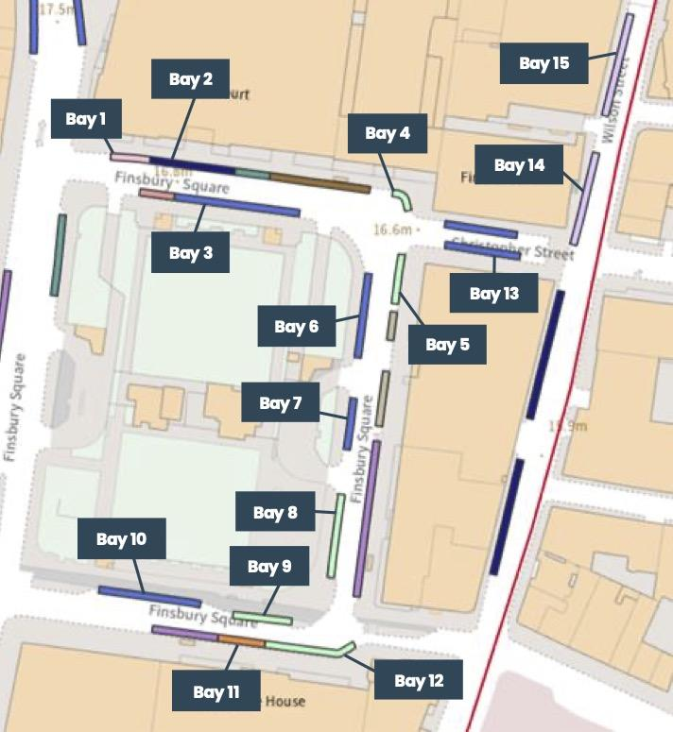

Finsbury Square – North Side
Bay 1 - 2 x car club spaces (north side outside 14-18) | YES/NO
Bay 2 - 4 x shared use spaces (north side outside 14-18) | YES/NO
Bay 3 - 7 x PbP spaces (north side opposite 14-18) | YES/NO
Bay 4 - 3 x motorcycle spaces (north-east corner) | YES/NO
Finsbury Square – East Side
Bay 5 - 3 x motorcycle spaces (east side close to 30) | YES/NO
Bay 6 - 4 x PbP spaces (east side opposite 30) | YES/NO
Bay 7 - 2 x PbP spaces (east side opposite 33) | YES/NO
Bay 8 - 5 x motorcycle spaces (east side opposite 30-37) | YES/NO
Finsbury Square – South Side
Bay 9 - 3 x motorcycle spaces (south side opposite 39) | YES/NO
Bay 10 - 5 x PbP (south side opposite 45) | YES/NO
Bay 11 - 2 x business spaces (south side) | YES/NO
Bay 12 - 5 x motorcycle spaces (south-east corner) | YES/NO
Christopher Street
Bay 13 - 4 x PbP spaces (south side) | YES/NO
Wilson Street
Bay 14 - 5 x permit spaces (west side outside 69) | YES/NO
Bay 15 - 5 x permit spaces (west side outside 26) | YES/NO
Start date and time (DD/MM/YY – XX:XX)
End date and time (DD/MM/YY – XX:XX)

Section 3 – Declaration
I declare that all information given in this application is true, and I understand that the suspended bay(s) are for film technical vehicles only, no private cars, unless agreed beforehand. By returning this form I confirm that I have read and accepted the essential information and guidance notes below.

Essential Information and Guidance Notes

Parking Bay
Parking Space 5m | Parking Space 5m | Parking Space 5m | Parking Space 5m | Parking Space 5m | Parking Space 5m

Business charge (When work is being carried out by or on behalf of a business)

The cost for a business or utility company to suspend a space or whole bay will be £385.38 administration charge and first day parking per run of bays, then £100.00 for each subsequent parking space per day on day two, and £101.25 for each subsequent parking space per day from day three onwards, excluding Sundays and Bank Holidays.

Please email this form to: info@islingtonfilmoffice.co.uk

- Vehicles must not wait in a suspended bay and will be issued with a Penalty Charge Notice and subsequently relocated. However, vehicles that are listed in the application form can load and unload from the suspended bay(s) for as long as is necessary or may be used for such purposes as agreed. Details of any vehicles must be provided and agreed by Parking Services.
- Please check all receipts sent to you are correct, if there are any errors please email info@islingtonfilmoffice.co.uk
- The application must be submitted at least 14 days before the suspension start date for all Parking Bay types.
- We will suspend the area requested, or an equivalent nearby area and will notify our Enforcement Service.
- Advance Warning Notices will be at the location requested where possible 10 days before the suspension starts, but we cannot guarantee the area will be kept clear.
- To remove unauthorised vehicles parked in suspended bays contact our Parking Enforcement Contractor on 0207 527 7624, who will be respond subject to available resources.
- If the suspension needs to be extended, the request and payment of the extension must be received at least 4 working days before the current suspension ends.
- Once processed, suspension dates cannot be brought forward
- Failure to give sufficient notice will require a new application form to be submitted and standard charges will be applied.
- All cancellations or date changes of suspensions must be made by email.
- For cancellations, a refund may be arranged for remaining days providing the bays or spaces have been put back to use.
- A cancelled suspension may only be fully refunded if the advance warning notices have not been created and places in the parking bay.
- Equipment provided by Islington Parking Services must not be moved, changed or removed.
- Advance warning notices and cones remain the property of Islington Council and will be removed by Islington Parking Services.
- Parking suspensions are usually enforced in line with controlled parking zone hours, unless your application states 24hr enforcement.

Data Protection Statement
Personal data has been collected by London Borough of Islington in order to manage this application, under the Traffic Management Act 2004. Your personal data may be collected, processed, shared and retained in order to carry out the performance of a public task and fulfil our legal obligations in the following ways:
- Shared with Islington Streetworks Section for the purposes of co-ordinated street management
Data will be stored for a period of five years.

Your Data Rights
In relation to the personal data which we may hold about you, you have the right to request to:
- Be informed, have access or rectify incorrect information. You also have the right to object to or restrict our processing of your data.
- Under Data Protection law we must verify your identity and explain to you our reasons if we do not agree to carry out your request.

Contact and Further Information
If you would like more information about how we use your data, please read our Privacy Policy or you can listen to our Privacy Policy by telephoning 0207 527 2000. Data protection questions can be made by email dp@islington.gov.uk or in writing to Data Protection Officer, c/o Information Governance Team, London Borough of Islington, 4th floor, 7 Newington Barrow Way, London N7 7EP, You have the right to complain to the Information Commissioner’s Office at www.ICO.org.uk

