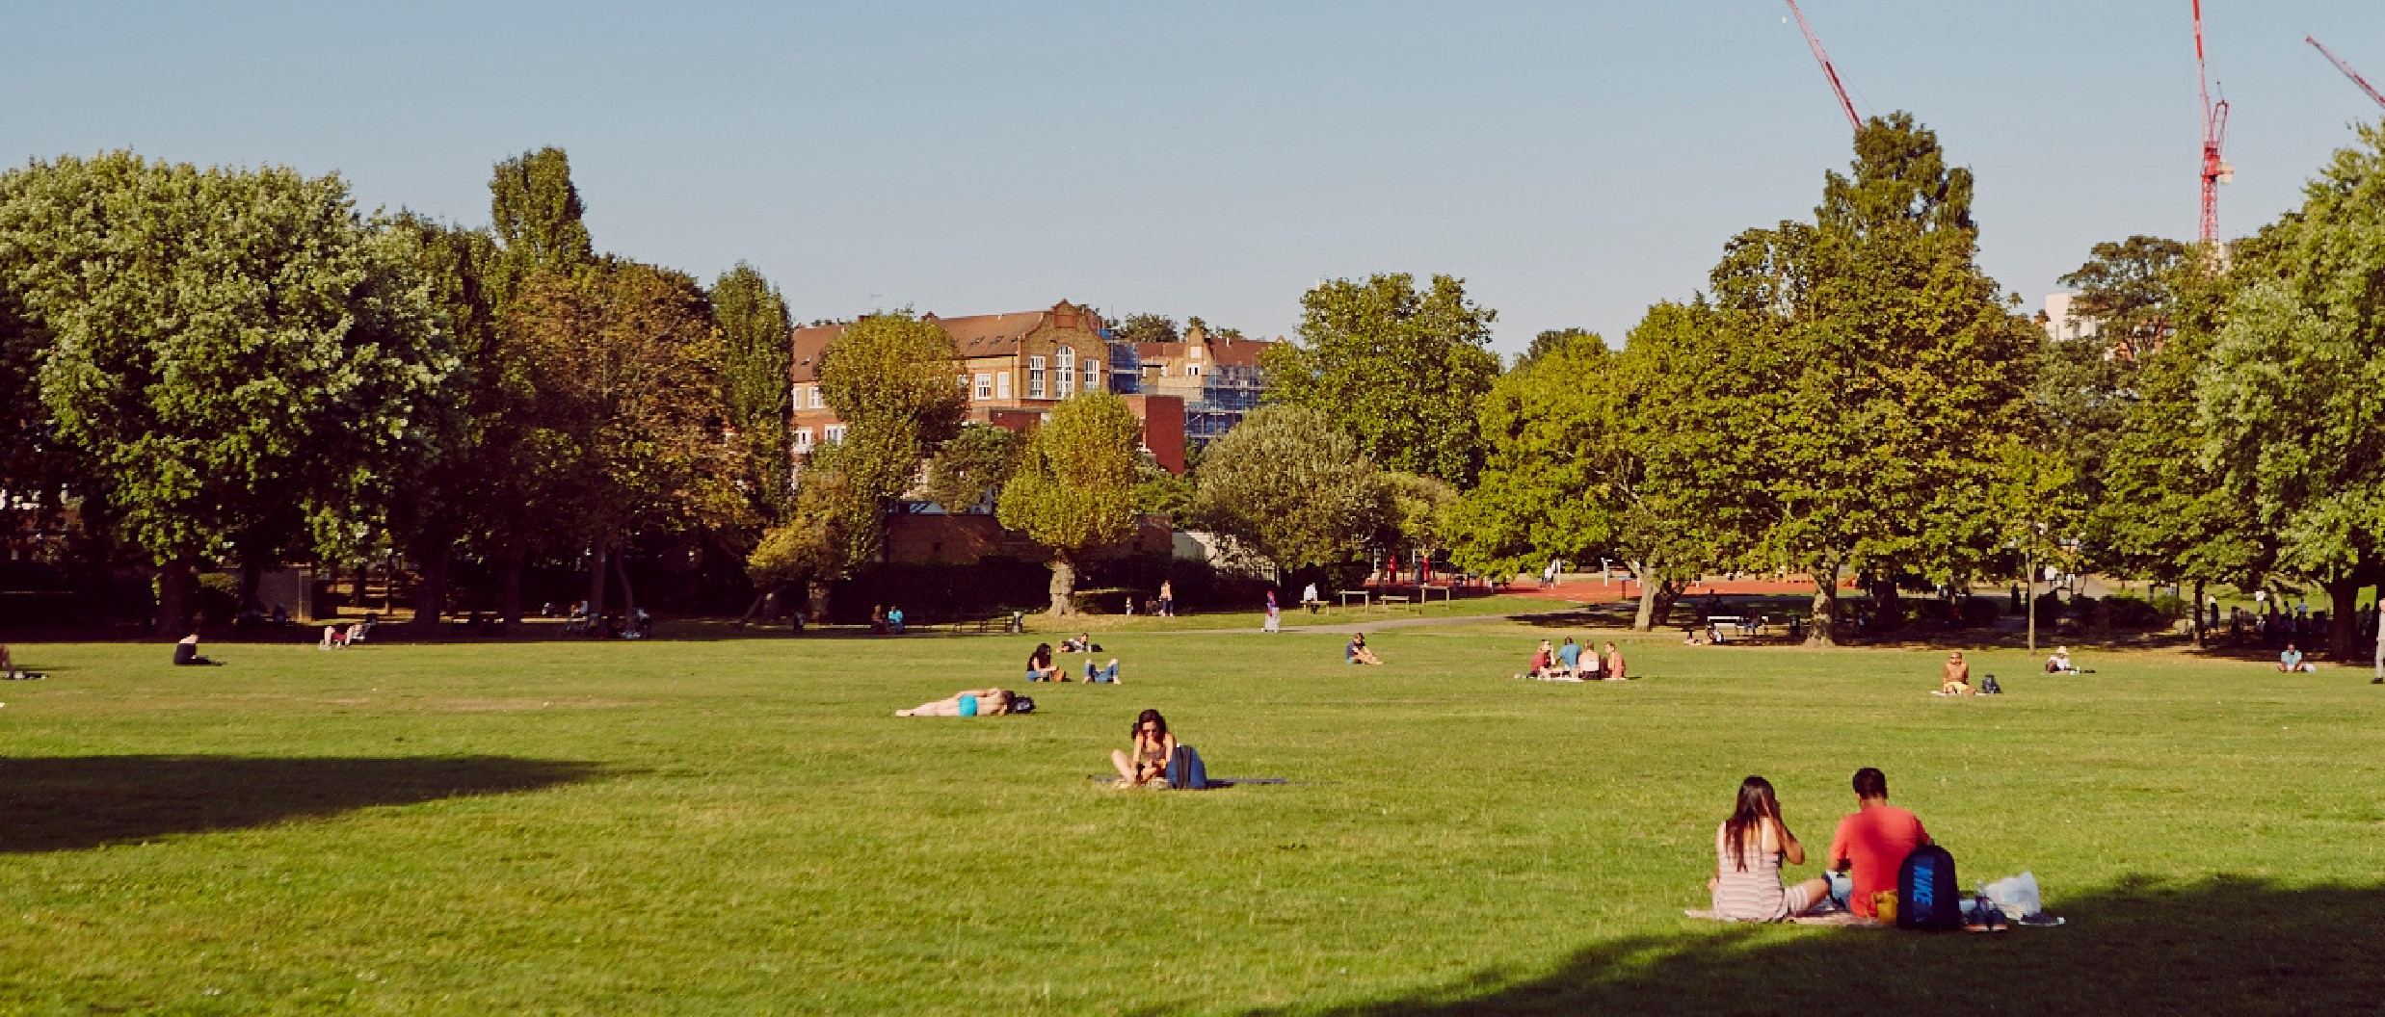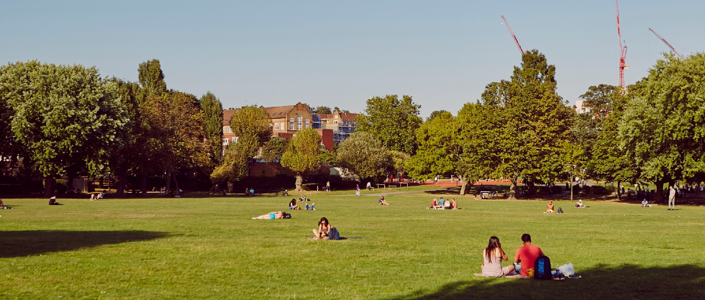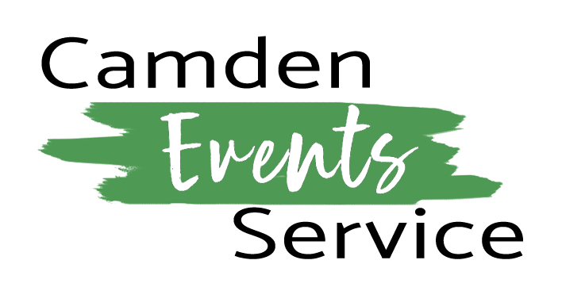

**Parks and Open Spaces Fees and Charges 2024-25**

|  |  |
| --- | --- |
| Community event – small scale, under 499 attendees at any one time | £100 |
| Small scale event half day, under 100 attendees at any one time | £387 |
| Small scale event full day, under 100 attendees at any one time | £774 |
| Midscale event half day, under 499 attendees at any one time | £629 |
| Midscale event full day, under 499 attendees at any one time | £1,276 |
| Commercial activity half day | £2,342 |
| Commercial activity full day | £4,685 |
| Large commercial event half day £5m+ | £3,304 |
| Large commercial event half day £5m+ | £6,536 |

Effective 1st April 2024 - 31st March 2025