Guidance for Events – Updated November 2022

This guidance note has been produced to assist smaller events where there is ordinarily no Safety Advisory Group, Police Counter Terrorism Security Co-ordinator and Counter Terrorism Security Adviser engagement. If you are the organiser of a larger event, you should consult the NaCTSO Guidance document: | ProtectUK and liaise with the Local Authority Safety Advisory Groups and Emergency Services as necessary. If you need further clarification, please contact the Counter Terrorism Security Adviser Team, details can be found at the foot of this document.

The parts of the UK most vulnerable to a terrorist attack are our crowded places, which may include events. In the wake of recent terrorist attacks in the UK and further afield, event organisers need to be increasingly mindful of their security arrangements. Use the advice below to help keep your event safe.

The Threat
Mi5 publish a national threat level to help the public plan for appropriate levels of security. Further information on the threat level to the UK can be found at: Threat Levels | MI5 - The Security Service

Critical
  An attack is highly likely in the near future
Severe
  An attack is highly likely
Substantial
  An attack is likely
Moderate
  An attack is possible, but not likely
Low
  An attack is highly unlikely

Response Level | Description | Threat Level
Normal | Routine protective security measures appropriate to the event | Low and Moderate
Heightened | Additional and sustainable protective security measures reflecting the broad nature of the threat with specific business vulnerabilities and judgements on acceptable risk | Substantial and Severe
Exceptional | Maximum protective security measures to meet specific threats and to minimise vulnerability and risk | Critical

A terrorist attack may take one (or a combination of) the following forms-
Vehicle Borne Improvised Explosive Device (IED) – use of an abandoned vehicle or by using a vehicle to penetrate an area.
Vehicle as a Weapon (VAW) – deliberate use of a vehicle driven into a crowd of people.
Person Borne IED - such as the tactics used by a suicide bomber.
Placed IED - something deliberately placed to detonate, it could be disguised.
Marauding Terrorist Attack - where a bladed weapon or firearm is used in a marauding attack.

If an attack were to occur at your event, use the METHANE mnemonic when informing your event security and the police of the incident:

M Major Incident declared
E Exact Location
T The Type of incident
H Any Hazards
A Available Access /Egress routes for Emergency Services
N The Number and Type of casualties
E The Emergency Services required and already present
Protecting Your Event from a Vehicle used as a Weapon (VAW)
There are a number of ways vehicles can be used in an attack. The exact mitigation will depend upon the nature of the site and/or event. To assess the strengths and vulnerabilities of your site or event from vehicle-borne threats you may wish to seek specialist advice and guidance from a Police Counter Terrorism Security Adviser (CTSA). Many threats from vehicles can be mitigated by landscaping or the installation of physical measures which may be static or security controlled. These measures can be installed either on permanent or temporary basis. Hostile Vehicle Mitigation (HVM) is a range of tactics, which can include physical measures and procedures that may mitigate against a VAW attack There is no one solution to protect against the range of vehicle borne attack methods, thus a range of tactics should be used together to provide resilience and appropriate protection.
To assist in protecting your event, consider:
- If there are linear approaches to queues, consider the positioning of vehicles, planters, barriers etc. to protect the queue line but allow for evacuation and rapid escape routes for queuing people.

- Lawful positioning of machinery or street furniture such as large generators, skips, cherry pickers and forklifts at temporary events will offer limited protection and slow down a vehicle.

- The use of large vehicles to create soft road closures into an event footprint. This is a flexible solution to deploy, and can be redeployed and moved at short notice. They can be easily moved to permit authorised vehicular and/or emergency access. Work in partnership with other agencies such as your Local Authority to identify if they can assist with large vehicles such as refuse trucks.
The position of the vehicle should be considered, 90 (ninety) degrees to the direction of travel is optimal. The use of Vehicles IS NOT hostile vehicle mitigation and WILL NOT stop a determined vehicle, however in the absence of anything else can be a consideration.

- The use of pedestrian barriers or fencing can be deployed to act as a slowing mechanism. It WILL NOT mitigate vehicle borne threats but if this is all that is available, then its use can be considered.

Please consider the below if using a vehicle as a barrier.

- The majority of vehicles are not rated to IWA 14 / PAS 68 / C-VAW (HVM standards) and will not provide adequate protection. There is a limited range of large vehicles that have been tested by CPNI which may offer effective deterrence and disrupt smaller attacking vehicles.

- How the vehicle is positioned and therefore its ability to protect the event.

- If a vehicle is used as a barrier then consideration must be made to overmatch this against the threat that is expected.

- Vehicle and occupant/driver safety and insurance liability.

- The security of the vehicle and potential for it to be stolen or hi-jacked by a hostile.

- Consideration of where the keys and driver are so the vehicle can be moved quickly if required. Which should include the provision for efficient emergency services vehicle access should be a key consideration.

- Vehicles may be positioned as a traffic calming measure causing the hostile vehicle to reduce its speed and potentially providing time to alert crowds.

- Consider the impact of crowd flow, particularly in an emergency evacuation situation.

There are other tactics that should be deployed to compliment a holistic HVM scheme such as:

- Staff briefings
- Signage
- Alert Systems - how will you alert visitors to an incident?
- Response measures
- Increasing soft vehicle closures to provide more standoff and increase response time.
- ‘Actions on’ Protocols - immediate actions if staff become aware of a hostile vehicle.

There are a range of more permanent Hostile Vehicle Mitigation (HVM) options to supplement the aforementioned forms of reduction/mitigation if the threat determines. These include:
- Total traffic exclusion from an area with suitable security arrangements to enforce.
- Traffic exclusion but with screening of all vehicles entering the area.
- Traffic inclusion/free flow within an area but with all critical /vulnerable assets within that area protected with tested and approved traffic calming and barriers (HVM)
- Temporary/supplementary tested and approved barriers deployed.
If you feel the above more permanent measures are necessary, you should contact a Police Counter Terrorism Security Adviser or Police Counter Terrorism Security Coordinator for specific advice.

Even with extensive plans to mitigate the use of a vehicle as a weapon attack, there remains a real tendency for staff at closure points to facilitate ‘blue light’ response or allow emergency services vehicles access through closure points without question. Fully liveried and blue-light enabled emergency services vehicles are readily available to purchase through online sites and physical auction sites. The use of ambulances by deception to penetrate a site has been seen overseas. This type of attack can be achieved by use of a purchased or stolen emergency services vehicle or by the hijack of such a vehicle either outside of the event area or already within the event area. There is significant vulnerability introduced to an event without a process for verification of emergency vehicles and personnel seeking access and a lack of control of vehicles once legitimately within the footprint.
- Where a vehicle management or exclusion zone is being developed for a crowded event area, there must be early engagement with all emergency services and local NHS Trust to consider the wider impact, especially where key healthcare facilities fall within the zone.

- The local NHS Ambulance Trust should be engaged at the earliest opportunity to ensure that they represent the views of the wider healthcare agencies during planning. This should involve the consideration of links with event, voluntary and private sector medical providers that may be impacted by the event plan.

- Any blue light response by any emergency services vehicles must be notified in advance by the relevant service control room through to the event control room. Details of the responding vehicle and reason for the response must be given and an access point agreed. At the access point, the vehicle details should be confirmed and occupants’ identification checked before granting access.

- Some basic good practice should be followed for all vehicles within the vehicle exclusion or managed zone, and they equally apply to emergency services vehicles

- When not in use, all vehicles within the event area must be locked with the keys inaccessible to members of the public.

- During the main event period there should be a vehicle curfew with no vehicle movements other than specifically approved.

- The vehicle should be switched off and locked at all times when not on the move.

- Non-essential event vehicles should be parked outside of the event footprint throughout the event.

- Standard practice of coach drivers sitting alone with engine running should be banned with officers and event security staff briefed to check for compliance.

Instructions on Finding a Suspicious Package

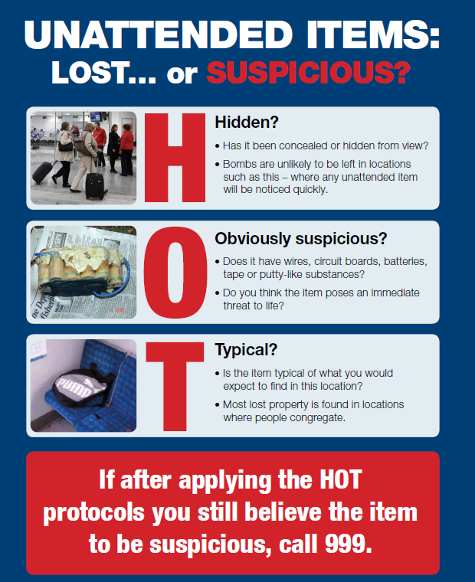
If you find a suspicious package at your event follow the 4 C’s:

Confirm the package is suspicious using HOT (see illustration). Consider who should be contacted at your event.
Radios/mobile phones should only be used behind hard cover and at least 15m away from the package. Clear the area of visitors and staff in a calm but assertive manner. Cordon off the area to ensure no one is able to return to the area.

The poster is available at to download: https://assets.publishing.service.gov.uk/government/uploads/system/uploads/attachment_data/file/563349/HOT_Poster_NaCTSO.pdf

Suggested minimum cordon distances are shown below, these may need to greater if your event is in open space.
100 Metres Minimum

200 Metres Minimum

400 Metres Minimum

Remove, Remove, Remove

Security personnel and other staff may be the first responders to an incident where people have been exposed to a hazardous substance. The REMOVE, REMOVE, REMOVE protocol is closely aligned to guidance for the Emergency services and provides simple, consistent advice on early actions following:
- Suspected deliberate or accidental exposure to a hazardous substance (vapour, powder or liquid)
- An ‘acid attack’
‘REMOVE, REMOVE, REMOVE’ is designed to be easily understood, remembered and applied.
The advice can be implemented without specialist protective equipment and is relevant for any potential hazardous substance incident, enabling any responder to provide an effective initial response until the emergency services arrive and beyond. The protocol is endorsed by Public Health specialists, as well as all three emergency services who are embedding it throughout the UK.

Points to consider in an Event Plan

Hostile Reconnaissance is the term given to the information gathering phase by those individuals or groups with malicious intent. Remain vigilant! Make sure your team know how to identify suspicious activity and where to report it. Benefits of being vigilant to Hostile Reconnaissance will not only reduce vulnerability to a terrorist attack but to general criminality.
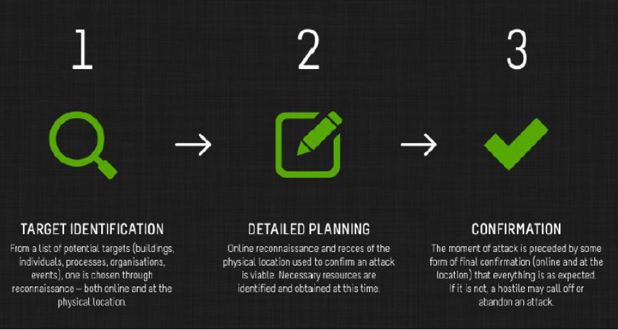

Be vigilant to:
- People asking unusual questions about security arrangements
- Filming, taking notes or photographs, or watching for extended periods, focusing on security cameras, hallways, fire exits and access/egress routes.
- People behaving strangely, e.g. nervous, perspiring, wearing overly warm clothing, concealing their face
- People bringing unusual packages into your event
- People found in off limits areas, particularly near plant or server rooms or places of concealment
- Vehicles parked in suspicious circumstances

Generally, the more sophisticated the attack the more complex the attack planning, and consequently the greater the information requirement and reconnaissance needed. The information gathered is used by terrorists in three main ways, to:

- Assess the state of security and likelihood of detection during reconnaissance and the attack itself
- Assess vulnerabilities in security and how these could be exploited to achieve the desired effects
- Inform the modus operandi and assess likelihood of success
Deny, Deter, Detect

Once it is understood what an attacker is looking for and why, event organisers can shape its protective security and other resources, to help disrupt hostile reconnaissance. CPNI research has shown that there are three principle ways that this can be achieved – DENY, DETECT and DETER
Deny
- Deny the terrorist reliable information by ensuring that the information is not readily available to them when it doesn't need to be (e.g. site plan on the event website); physically, or via people who work at the site.
Deter
- Provide integrated, effective detection capabilities focussed in the right areas (i.e. where hostiles will have to come to obtain information) e.g. functioning well-sited CCTV and proactive control room staff.
Detect
- By promoting DENY and DETECT capabilities to the attacker that shape their perception and assessment of likely failure both of the reconnaissance and the attack itself

Countering the threat: CPNI advice

Event organisers can help reduce their vulnerability to online and physical hostile reconnaissance by considering the following:

- Secure online presence – As an event, you should think about the information that is put in the public domain?
- Robust entry process – Are your security personnel sufficiently motivated to identify, deter or detect hostile reconnaissance?
- Hostile reconnaissance points understood
- Strong staff security awareness
- Vigilant and professional security

Security minded communications

This short guidance note provides assistance from the Centre for the Protection of National Infrastructure (CPNI)’s in using Security-Minded Communications; how to utilise professional communications to help deter terrorist attack and wider criminality whilst simultaneously informing, reassuring and potentially recruiting the normal event goer to assist. How an organisation provides its messages and evidence of these capabilities needs to be done carefully and thoughtfully. For example, being considerate of the normal site user and their perceptions of such messages (ideally to be reassuring and informative) and critically, to convey the protective security without giving away detail that could be helpful to hostiles.

For example:

“We have airport style screening at our event and a range of secondary security measures some of which may not be visible”
“Your security is important to us, to keep you safe, we are doing....”
“Help us to keep you safe, if you see something suspicious, tell one of our team”
“To keep you safe we will be conducting extra searches, you can enter through our fast lane if you don’t have a bag”
“To speed up the security process, please keep bags to a minimum.

Opportunity for Security minded communication should be considered in the lead up to and during the event. The aim for this communication should be;

Discouragement; leveraging communications to relay messages so that criminals will find it difficult to target the event. Proactively communicating the effective security capabilities of the site may result in a potential attacker discounting the site.
Non-encouragement; ensuring communications do not say anything that makes the criminal think security will be a ‘doddle’ or that provides a criminal with knowledge of particular security measures in place.
As an event organiser, you may wish to follow Counter Terrorism Policing on Social Media and retweet and share relevant messages. This re-emphasises that your site and staff are terrorism and threat aware.

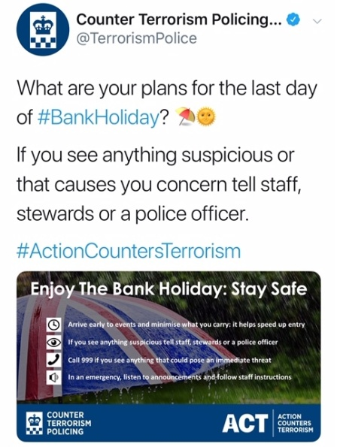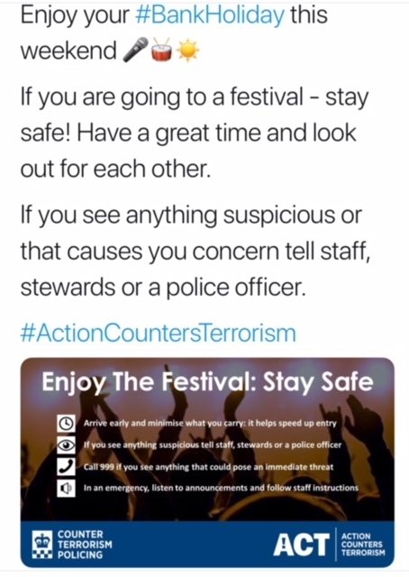
Weapons and Firearms Attack

Lockdown Guidance
The Government’s RUN, HIDE, TELL guidance explains how to keep safe during a marauding firearms or weapons attack. It was devised by analysing how people survived in terrorist firearms/weapons attacks: -https://assets.publishing.service.gov.uk/government/uploads/system/uploads/attachment_data/file/595437/RHT_A5.pdf
It advises people to RUN away from danger if possible, if that is not an option people should aim to HIDE and lockdown the area around them. Find cover from gunfire; cover from view does not mean you are safe, bullets go through glass, brick, wood and metal so move away from doors. Be aware of your exits and try not to get trapped and lock / barricade yourself in. Finally if it is safe to do so, dial 999 and TELL the police what is going on and what you have seen.
The sooner the emergency services have a clear picture of what is occurring the sooner they will be able to intervene.
Tell the emergency services your location - Where are the suspects? Direction - Where did you last see the suspects? Descriptions – Describe the attacker, numbers, features, clothing, weapons etc. Further information – Casualties, type of injury, building information, entrances, exits, hostages.

In Summary, prior to your event:

- Encourage staff to actively monitor news and media sources to maintain their situational awareness.

- Review your security plans to ensure that they are fit for purpose and ensure that your staff, volunteers and where appropriate visitors or contractors are aware of their contents.

- It would be easy to concentrate on a Person Borne IED as the threat, however you should ensure that you focus your planned response on the full range of potential terrorist attack methodologies, particularly those from vehicle as a weapon, bladed weapons and IED’s (person borne, placed or vehicle), although other methodologies should be actively considered.

- You should ensure that where you decide to instigate additional security or other measures that all your staff at the relevant locations are briefed, know their roles and responsibilities, and have access to the relevant corporate plans, policies and guidance.

- You should consider how your resources and capabilities are deployed to deter, detect and disrupt and thus defeat hostile threat actors and terrorists:

To do this you would want to consider the following:

  - The use of your communication channels to reassure legitimate users of your sites and to project a hostile operating environment for threat actors.
  - The proactive deployment of security resources to conduct unpredictable security activities both within and in the footprint around your sites and venues to deter hostile reconnaissance and detect suspicious behaviour. They should be encouraged to engage individuals acting anomalously to determine what the cause is.
  - Ensure all staff take responsibility for security, not just security personnel. They should be reminded to be vigilant, and use their customer service skills to proactively engage with customers, visitors and others.
  - Active engagement with customers, visitors and individuals at or in the vicinity of locations in the way described above is both an opportunity to help and reassure legitimate site users and, in context to, deter or detect hostile threat actors.
  - Engage with your neighbours to ensure that your plans and activities are mutually supportive. In particular you may wish to ensure that any security activities are coordinated to ensure that gaps and inefficiencies are avoided.
  - Ensure that your staff are briefed on the threat and what constitutes suspicious behaviour. They will know what is normal for their regular places of work and what is not, positively encourage them to investigate or report things which feel out of place to the ordinary and have mechanisms to escalate such reporting.
  - Ensure that your personnel are aware that ethnicity, religion, colour, clothing, and gender are not helpful in identifying hostile threat actors or terrorists. However such individuals are likely to display suspicious or non-baseline behaviours. Again it is important to stress that this different behaviour may have many causes both benign and malign, and is not an indicator of terrorism. It is only through identifying, engaged and assessing why someone is behaving differently that a conclusion can be drawn.

- Consider your action on suspicious activity and object reporting
  - What are your ‘action on’ plans if your security or staff identify a suspicious individual or objects outside or inside your premises?
  - Are your staff aware of their options for Evacuation/ Invacuation/ Lockdown procedures, and do your plans include provision for vulnerable staff and visitors?
  - Do your staff know where the emergency assembly points?
  - Have you identified any protected spaces within your venues and do staff know where they are?
  - Are your staff lists up to date and accessible so that you can account for them in the event of an incident?

- Search and Screening

- Given finite resources you should consider focusing it on addressing your highest priority threats
- Configure your search regime to the threat you are looking to mitigate – E.g. prioritise detection of larger threats, accepting smaller items may not be detected If you are primarily worried about mass-casualty threats, don’t look for penknives
- Configure any search and screening regimes to minimise queues

- Stadia and venues specific considerations:

In addition stadia and venues may additionally wish to consider the following:

- Continually review event schedules and associated safety & security plans against the changing threat picture.

- Consider staged or managed dispersal through multiple exit points to minimise crowd densities at the end of an event

- Consider security and perimeter surveillance at of all stages of event. In particular consider how you manage the dispersal phase of an event and how you use your personnel and security resources to continue to recognise and react to suspicious behaviour and objects.

- Ensure activity deployed to identify and act on suspicious behaviour is maintained for the dispersal phase of an event and that known entry and exit points are considered within any plan.

- Consider your extended footprint as part of any security and safety planning/ activity

- Consider maintaining the same perimeter control measures at the end of an event as you would at the start.

- Ensure that the public are aware of enhanced security measures before arrival to enhance compliance and ensure that they do not bring items that would slow down any search regime you have in place.

- Consider your ability to actively message staff and visitors within your venue to pass on instructions or information in the event of an incident or response to a threat.

Encourage the use of the ‘Sixty Second Security Check List’. This is a quick list of security minded questions that all event staff should know the answers to in order to improve reactions to emergency situations:
- Who is appointed to make decisions at the event, and do they know what they're doing?
- How do you enter and exit the event in emergency?
- How do you lock down quickly? (if applicable)
- Where can you hide?
- How do you communicate and how do you stay updated if you find yourself in a Run, Hide Tell scenario?
- Have you briefed this to your staff?
- Does everyone know the plan?

For further information on anything within this guidance, please visit:

National Counter Terrorism Security Office - | ProtectUK

Centre for the Protection of National Infrastructure - www.cpni.gov.uk

Complete ACT e-learning: An interactive online product designed to provide nationally accredited counter terrorism awareness to all. (45 minutes) - E-Learning | ProtectUK

Download the Protect UK App and Sign Up to the ProtectUK Website:
Sign up to the new ProtectUK Platform for advice, guidance, webinars, forums and details and downloadable resources relating to Vigilance Campaigns.
Register here: https://matomo.protectuk.police.uk/78ce46
Download the ProtectUK App via Apple Store or Google Play for Action Cards and News Updates.

Distribute new CT Policing Z – Card: An aide memoire that gives advice and guidance on ‘run, hide, tell’, actions for suspicious items, hostile reconnaissance, HOT principle, cordons, reporting incidents, CBRN and decision making.

Contact us
Counter Terrorism Security Advisers (CTSAs) can provide support and guidance to enable you to run a safe and successful event. A self-delivery PowerPoint presentation is also available to your event staff. Please contact the team on: ctsakent@thamesvalley.police.uk
Counter Terrorism Security Adviser Team
CT Policing South East
30th November 2022

You can report suspicious behaviour in confidence, it is quick and easy:

Online via our secure form: www.gov.uk/ACT

By phone confidentially and anonymously via the Anti-Terrorist Hotline on 0800 789 321

We thank you all for your hard work at this difficult time. Take care, stay safe.

NB – There is no intelligence and no increase in threat; this is standard advice for crowded places.

